This tool focuses on 4 Elements of Implementation and 4 Stages of Development. It provides guidance questions and resources for the District or School in each of these areas.
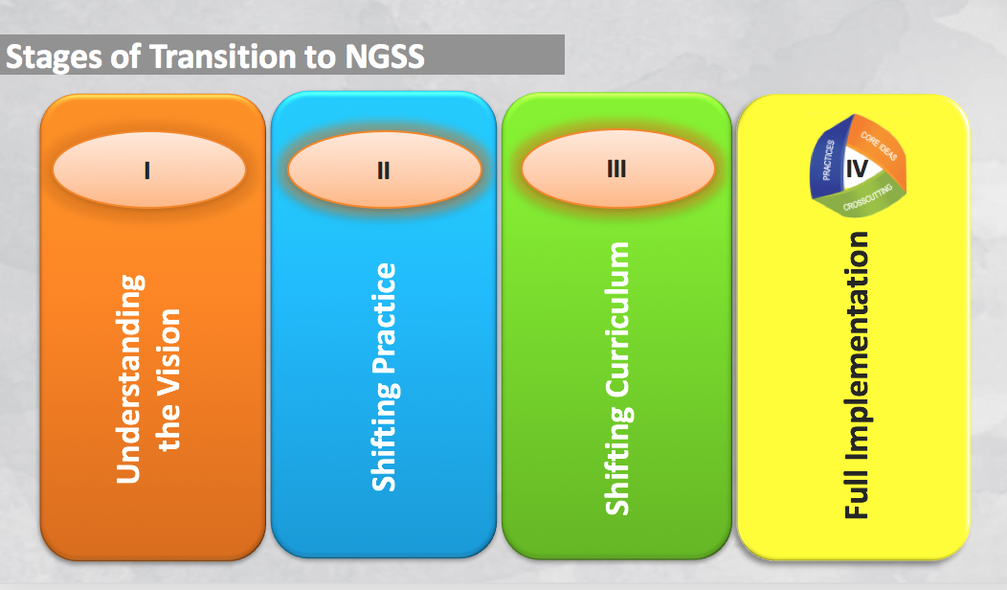
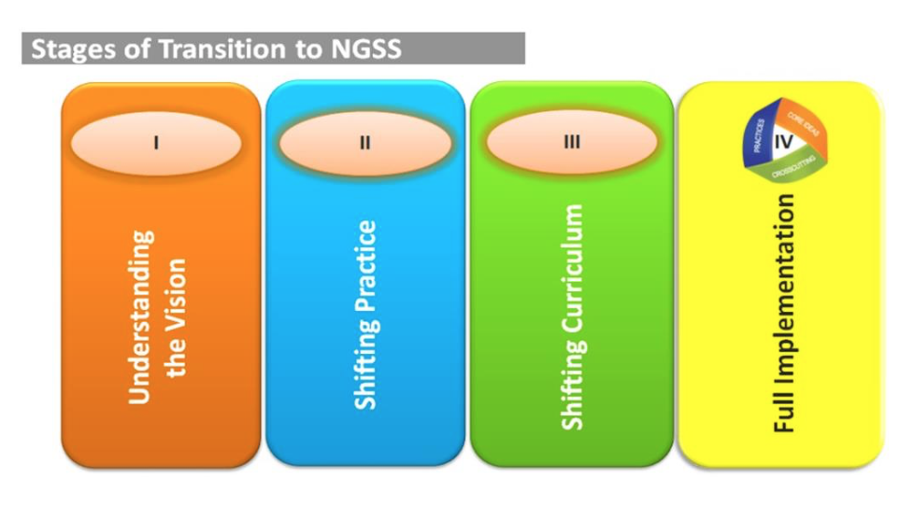

Teacher & Leadership Learning
Recommendation 5 | Train, identify, and designate leadership teams (PLCs, Committees or Departments) to lead implementation efforts.
Questions:
- Who are the local science leaders?
- How will the teams be organized? Whole district? Grade level teams? Building level departments?
- How often will groups or subgroups meet?
- What professional development and support is needed to build capacity?
Resources:
NGSX
Professional Development that Supports NGSS: STEM Teaching Tools
Professional Development Priorities: STEM Teaching Tools
Recommendation 6 | Develop a comprehensive, multiyear plan to support teachers’ and administrators’ learning and progress toward implementation.
Questions:
- 4 Phases of Implementation:
  - Understand the VisionShift Classroom PracticesShift and Align Curriculum
  - Full Implementation
- How will the leadership team prioritize critical implementation steps?
- What local systems are in place that support the vision?
- How will the team communicate the plan to the stakeholders?
- How will resource allocation be determined?
- What professional development and support is needed?
Resources:
4 Year Strategic Planning Timeline (Fill In)
Guide to Implementing NGSS
MDE Science Homepage

Instruction (page 1)
Recommendation 1 | Establish, support and communicate a vision for 3-Dimensional K-12 Science as outlined in the NRC Framework and Michigan Science Standards.
Questions:
- What instructional models support the shift from “learn about” topics to “figure out” phenomena?
- How will the leadership communicate these shifts to all stakeholders?
Resources:
What’s Different: STEM Teaching Tool
- Ambitious Science Teaching
Science Instruction Blueprint Tool
Instructional Models for Science: STEM Teaching Tool
Recommendation 2 | Provide support for teachers and administrators to make incremental, consistent progress toward the vision.
Questions:
- How does the current teacher evaluation model support the instructional shifts in science? (See also, Recommendation 3)
- How do the instructional shifts align with other district and/or building initiatives?
- What professional development and support is needed to understand the vision and shift practice?
Resources:
Science Instruction Blueprint Tool

Instruction (page 2)
Recommendation 3 | Shift classroom culture toward 3-Dimensional student-centered inquiry as described in the Michigan Science Standards.
Questions:
- Is student work in science class focused on explaining phenomena or solving problems?
- Are students engaged in productive talk?
- Are students engaged in using practices and cross-cutting concepts?
- Is teacher work focused on “fixing” student misconceptions or recognizing, building, and responding to the range of student ideas about science?
Resources:
Beyond Misconceptions: STEM Teaching Tool
Learn Science through Productive Talk: STEM Teaching Tool
Video Case Studies: Ambitious Science Teaching
Video Case Studies: Inquiry Project / Science Talk
Recommendation 4 | Establish assessment as an integral part of instruction: embedded formative assessments and summative performance tasks.
Questions:
- What formative assessment strategies are currently used in classrooms?
- How are performance tasks used in summative assessments?
- What kinds of rubrics are used to help teachers assess student performance?
- What processes are in place for teachers to review student work?
Resources:
Using Summary Charts to Press for Evidence and Build Coherence
Assessment Series: STEM Teaching Tools

Curriculum Materials
Recommendation 9 | Provide teachers with training, guidelines, and tools to revise or adapt existing curriculum materials in support of the vision.
Questions:
- What materials are currently in place? Can current materials be aligned or adapted?
- What evaluation tool will guide the decision making process?
- What is the timeline for pilot, adaption, or adoption?
- What is the budget for consumables as student engage in science & engineering practices?
Resources:
Adapting Existing Curriculum for NGSS: STEM Teaching Tools
5 Tools for Translating NGSS into Instruction
Recommendation 10 | Facilitate decision making processes to determine the scope and sequence.
Questions:
- Will K-5 units be organized by Topic or by the adopted curricula?
- Will 6-8 courses be organized by Topic, Conceptual Progression, or Domain Specific Model?
- Will 9-12 courses be organized by Topic, Conceptual Progression, or Domain Specific Model?
Resources:
Sample Course Mapping for Michigan
Course Mapping for MS/HS: Appendix K
Recommendation 11 | Establish a clear set of measures and tools to evaluate whether new materials are consistent with the vision.
Questions:
- What materials will be considered for adoption?
- What is the local curriculum adoption process?
Resources:
EQUiP Rubric for Science Lessons and Units
Evaluating Curriculum Materials for NGSS: STEM Teaching Tools

Assessment
Recommendation 13 | Create a balanced system of assessments to monitor student progress toward the performance expectations.
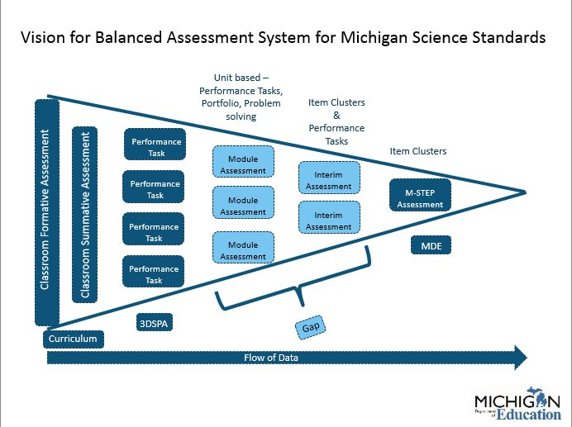
Questions:
- How will student learning be assessed at the Classroom level? Building level? District level?
- What evidence of learning is being collected?
- How is progress reported?

Resources:
A Balanced Assessment System: STEM Teaching Tools
Assessment Series: STEM Teaching Tools
Recommendation 14 | Support teachers’ use of appropriate formative assessment strategies of student thinking to inform ongoing instruction. (See Recommendation 4)
Questions:
- What formative assessment strategies are currently used in classrooms?
- How can teacher’s use science and engineering practices + productive talk strategies to inform instruction and guide student learning?
Resources:
Formative Assessments for NGSS: STEM Teaching Tools

