Unit 1 Assessment

C2.5a
1. Define Half-life
* The time it takes for half of a radioactive sample to decay

2. How can the concept of half-life be used to determine a material’s age?
* C-14 decays naturally. As long as a plant or animal is alive, the amount of C-14 remains the same (as C-14 in the atmosphere). When the organism dies, the C-14 begins to decay and is not replaced. The fraction of C-14 can then be used to determine the age of the dead organism

3. A radioactive sample has a half-life of 10 days. After 50 days, what fraction of the sample is still radioactive?
a. 1/50 b. 1/32 * c. 1/16 d. 1/10

4. A radioactive substance has an original mass of 80.0 grams. After 4 half-lives, what mass is radioactive?
a. 5.00 g * b. 10.0 g c. 20.0 g d. 40.0 g

5. Carbon-14 has a half-life of 5715 years. A fossil bone has been discovered that contains 1/16th as much carbon-14 as a living bone sample. How old is the sample?
- The fossil sample is 5715 years old.
- The fossil sample is 11 430 years old.
- The fossil sample is 17 145 years old.
- The fossil sample is 22 860 years old. *(4 half-lives)

C3.5a

1. In a nuclear reaction _________________________

a. electrons move closer to the nucleus
b. a new compound is formed when the nuclei of two different elements share
electrons
* c. an atomic nucleus gains or loses protons to form a different element
d. nuclear mass is constant and energy is produced

2. Fusion or fission?

_______ a. the splitting of a large atom into two or more smaller atoms
_______ b. the principle source of stellar energy
_______ c. nuclear power plants
_______ d. the joining of two atoms to produce a larger atom

* a. fission b. fusion c. fission d. fusion

3. The law of conservation of mass is true for_________________

a. chemical and nuclear reactions
b.. fusion and fission reactions
c. fusion reactions, but not fission reactions
* d. chemical reactions, but not nuclear reactions

4. How does the law of conservation of mass-energy apply to nuclear reactions?

* In nuclear reactions, some of the mass of the reactants is converted to energy. The amount of energy is determined by the formula E=mc² (E=energy, m=mass, c=speed of light)

5. The mass of a helium nucleus is slightly less than the sum of its parts (2 protons & 2 neutrons) because

a. some of the mass is converted to binding energy *
b. some of the mass is given to electrons
c. the mass of protons and neutrons are not precisely known
d. nuclear scientists can't add

C4.7b

1. Which of the following is the correct formula for determining density

a. Density = mass/volume * b. Density = volume/mass
c. Density = mass x volume d. Density = mass – volume

2. A liquid fills a graduated cylinder to 43.2 mL and has a mass of 57.8 grams. Calculate the density of the liquid.

* 1.34 g/mL

3. A piece of wood has a length of 14.30 cm, a width of 6.70 cm and a height of 3.40 cm. The mass of the wood is 200.9 grams. Calculate the density.

* 0.616 g/cm³

4. Gold has a density of 19.3 g/cm³. A gold medallion has a mass of 57.4 grams. What is the volume of the gold medallion?

* 2.97 cm³

5. A student determines the density of 4 standard sugar solutions (10, 20, 30 and 40%) and a solution of water only (0%). The data is plotted on the following graph. The student is then asked to find the % sugar concentration in an unknown solution. The unknown solution has a volume of 50.0 mL and a mass of 52.5 grams. What would the approximate % sugar be in the unknown solution?

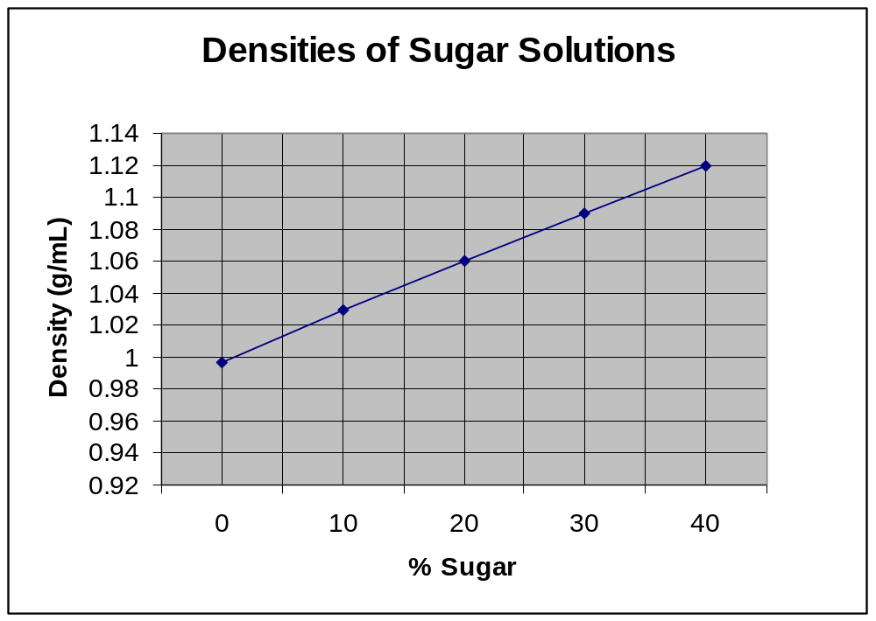

Answer: ~17% sugar

C4.8A

1. Which of the following statements is NOT correct?

a. protons have a positive charge
b. electrons have a negative charge
* c. protons and electrons would repel each other
d. neutrons do not have a charge

2. The nucleus of the atom is composed of:

a. protons and electrons
* b. protons and neutrons
c. electrons and neutrons
d. electrons only

3. The electrons of an atom can be found

a. in the nucleus with the protons
b. occupying the same space as neutrons
* c. traveling outside the nucleus in different orbitals
d. randomly scattered throughout the entire atom

4. All of the following are true except:

a. protons and neutrons have about the same mass
b. an electron has a mass almost 2000 times smaller than a proton
c. a proton has a mass of 1 a.m.u.
* d. protons and electrons have about the same mass

5. Draw a Bohr model of the atom for a neutral atom of chlorine

Answer:
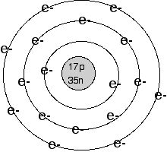

C4.8B

* Use the following diagram to answer the next 2 questions

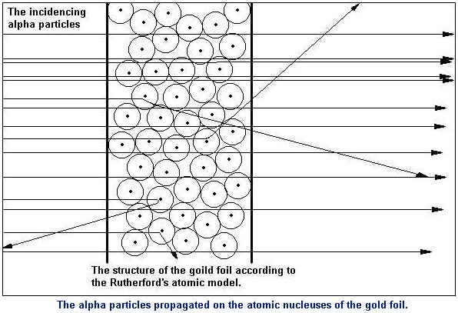

1. Which of the following best describes why most of the alpha particles past straight through the gold foil

a. alpha particles are repelled by electrons
* b. the atom is mostly empty space
c. the nucleus has an overall negative charge
d. the atoms are to small to affect the path of alpha particles

2. In the gold foil experiment, alpha particles occasionally display a backward deflection because of:

a. their attraction to the negatively charged electrons
b. the large size of the nucleus
* c. electrical repulsion occurring with the positively charged nucleus
d. direct collisions with the neutrons

3. After the gold foil experiment, Rutherford concluded that:

a. the atom was mostly empty space
b. atoms contain a small, dense center
c. the atomic center was positive in charge
* d. all of the above

4. According to atomic theory, electrons are usually found:

a. in the atomic nucleus
b. outside the nucleus, but very close due to their attraction to the protons
* c. outside the nucleus in a large area described as the electron cloud
d. anywhere within the entire atom

C4.8C
1. Scientists have determined that matter is affected by four fundamental forces in the Universe. Which one of the following is not a fundamental force?
a. frictional static *
b. electromagnetic
- strong nuclear force
- weak nuclear force

2. Which of the following subatomic particles would repel each other?

a. protons repel neutrons
- protons repel electrons
- protons repel protons *
- electrons repel neutrons

3. Why are enormous amounts of energy needed to separate the nucleus of an atom into its component protons and neutrons, even though protons in the nucleus repel each other?
a. the force of protons repelling each other is smaller than that of neutrons
attracting each other.
b. electrostatic forces acting between other atoms lowers the force of repulsion.
c. the interactions between neutrons and the electron cloud neutralizes the
repulsions between protons.
* d. the forces holding the nucleus together are much stronger than the forces of
repulsion between the protons.

4. Refer to the graph at the bottom of the page to answer the following constructed response questions.
- Use a ruler and a pencil to locate the position of each of the following isotopes on the graph.
¹⁰² Rh
⁴⁵

²⁰⁹ Bi
⁸³

- What can you say about the stability of each of the isotopes? Why?
- What would you predict about the stability of isotopes heavier than bismuth
(Bi)? Why?
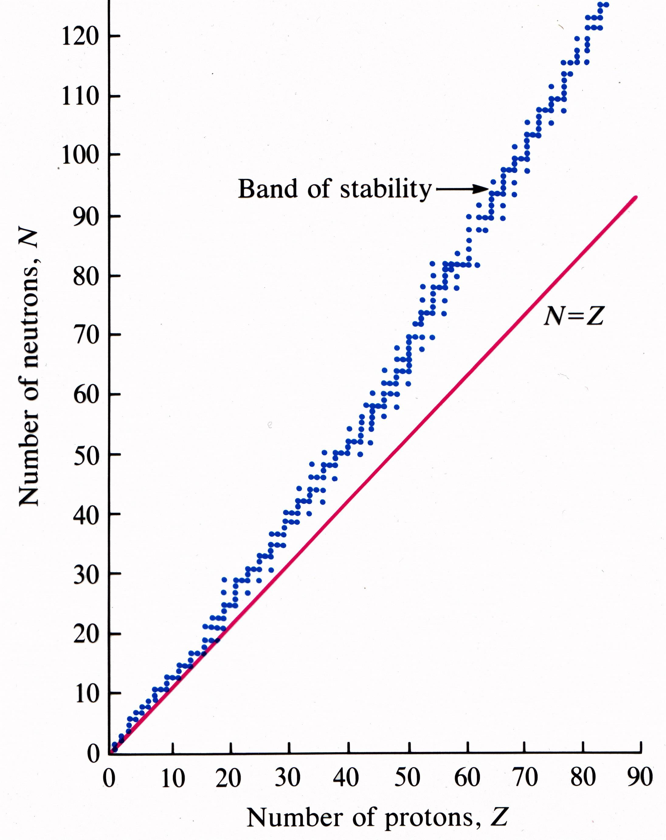

5. Determine whether the following statements about protons and neutrons are true or false? (T or F)
_______Protons are twice as massive as neutrons. (F)

_______Protons carry a +1 charge while neutrons have -1 charge. (F)

_______Protons and neutrons are both composed of particles called quarks. (T)

_______Protons and neutrons are both found in the nucleus of the atom. (T)

_______Protons contain 2 up quarks and 1 down quark. (T)

_______Stable nuclei for elements with atomic numbers less than 20 have a ratio of
protons: neutrons which is very close to 1:1 (T)

_______Isotopes of elements heavier than bismuth contain both radioactive and
stable isotopes. (F)

C4.8D

1. Define ion

* An atom or group of atoms that is electrically charged (gained or lost electrons)

2. How many valence electrons does a fluorine atom have?

a. 1 b. 2 c. 7 * d. 8

3. Fluorine would likely form bonds with all of the following atoms except:

a. sodium (Na) b. oxygen (O) *
c. potassium (K) d. Magnesium (Mg)

4. How many protons and electrons would an ion of fluoride (F ¹⁻) contain

a. 9 protons, 9 electrons
b. 10 protons , 9 electrons
* c. 9 protons, 10 electrons
d. 10 protons, 10 electrons

5. Using Bohr Models, draw the formation of LiF salt.

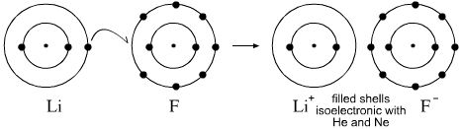

C4.10A

1. Identify the number of protons, neutrons, and electrons in the ⁴⁵Sc⁺³ cation.

Answer: 21 protons, 24 neutrons, 18 electrons

2. The ion ⁷⁹₃₅Br⁻¹ contains:

a. 35 protons, 44 neutrons, 36 electrons *
b. 35 protons, 44 neutrons, 34 electrons
c. 35 protons, 44 neutrons, 35 electrons
d. 44 protons, 35 neutrons, 36 electrons

3. Give the symbol of an ion which has 10 e⁻ and 7 p⁺.

Answer : N³⁻

4. Naturally occurring carbon consist of three isotopes, C-12, C-13, and C14.

Fill in the correct information for each isotope.
 | Carbon-12 | Carbon-13 | Carbon-14

Number of protons

Number of electrons

Number of neutrons

Answer
 | Carbon-12 | Carbon-13 | Carbon-14
Number of protons | 6 | 6 | 6
Number of electrons | 6 | 6 | 6
Number of neutrons | 6 | 7 | 8

5. Using a periodic table, fill in the missing information on the table below.

Element/Ion | Atomic Number | Mass Number | Protons | Neutrons | Electrons
⁷Li
 | 56 | 137 |  |  | 56
 |  |  | 20 | 20 | 18
¹⁹F⁻

*
Element/Ion | Atomic Number | Mass Number | Protons | Neutrons | Electrons
⁷Li | 3 | 7 | 3 | 4 | 3
¹³⁷Ba | 56 | 137 | 56 | 81 | 56
⁴⁰Ca²⁺ | 20 | 40 | 20 | 20 | 18
¹⁹F⁻ | 9 | 19 | 9 | 10 | 10

C4.10B

1. True or False: elements always contain the same number of protons

* True

2. Hydrogen (¹H), deuterium (²H) and tritium (³H) are isotopes.
Which of the following is true?

a. They have the same number of neutrons.
- They have the same number of protons. *
- They have the same mass number.
- None of these statements are true.

3. The atomic number corresponds to an atom’s number of____________

a. protons * _
b. neutrons
c. electrons
d. positrons

4. Which statement is NOT true about elements?
a. An element may consist of atoms and molecules.
b. There is only one kind of atom in each type of element. *
c. All atoms of an element contain the same number of protons.
d. Atoms of an element may contain different numbers of neutrons.

5. The atomic number of an element gives the number of __ and __in the atom.
a. protons, electrons *
b. neutrons, protons
c. neutrons, electrons
d. the atomic mass of the atom

C4.10e

1. Define isotope

* An atom that has the same number of protons as another atom, but a different number of neutrons

2. carbon-14 has more__________________ than carbon-12

a. protons b. neutrons *
c. neutrons and electrons d. electrons and protons

3. The element Chlorine has two naturally occurring isotopes. They are ³⁵Cl and ³⁷Cl. The ³⁷Cl isotope contains which of the following:

a. 37 protons and 17 neutrons
b. 17 protons and 37 neutrons
c. 20 protons and 17 neutrons
d. 17 protons and 20 neutrons *

4. Identify what A, X, and Z represent when using them for isotope notation

^{A}X_{Z}

* A = mass number
X = symbol of the element
Z = atomic number

5. Write the isotopic notation for the following atoms:

55 protons and 78 neutrons

27 protons and 32 neutrons

53 protons and 74 neutrons

Answers:

¹³³Cs₅₅ ⁵⁹Co₂₇ ¹²⁷I₅₃

