Learning Stream
  - Finding events, creating an account and registering for an event

Finding an Event
To find an event from the Wayne RESA Event Listing, you can either 1) enter an event number or title in the Search Criteria field and press Enter or 2) select a category from the Category drop down list. To clear the Search criteria entered, delete the entry and click on the View/Search Events.
To learn more about an event, click on the Learn More button for the desired event.

Creating an Account and Registering for an Event
NOTE: If you are currently registered for a Wayne RESA event, your login is your first initial + last name and any additional alpha characters to make an ID that is 8 characters long. You will be given a temporary password that will need to be changed. Please look for an email from Wayne RESA Events with your login/password.
After clicking on the Learn More button on an event, from the next screen click on the Register Now button.
You will then have the option to enter your login ID and password.
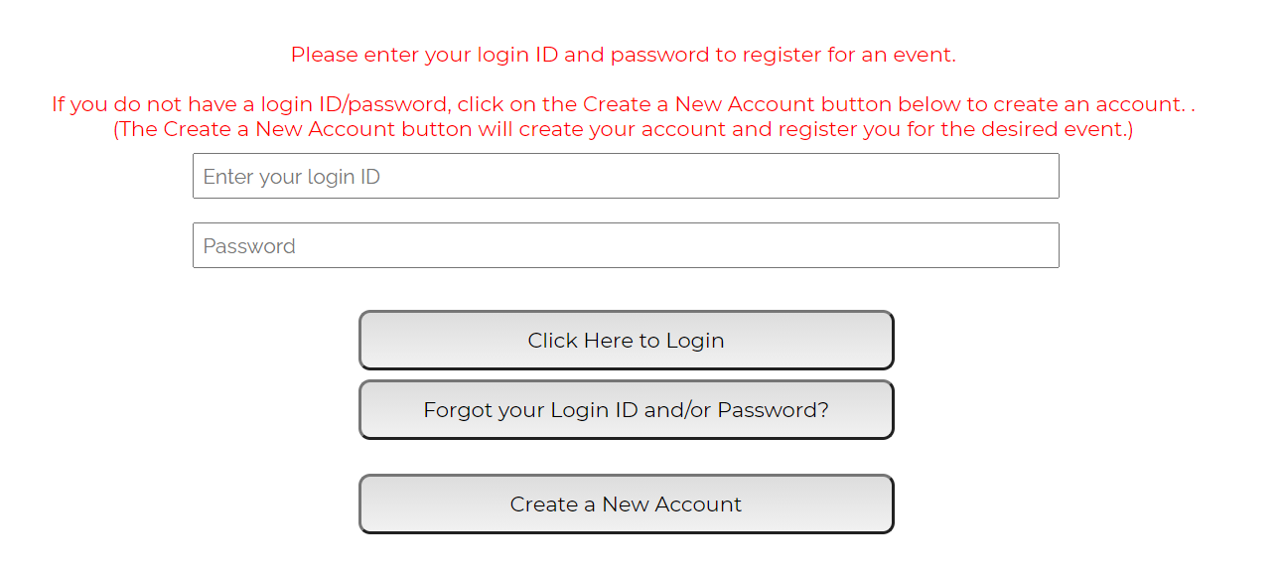
Or you can click on the Create a New Account button. The Create a New Account button will allow you to set up your Learning Stream account and register you for the desired event.

When creating an account, you will need to create a login ID/password and enter basic information such as name, email, phone number, address, district, building and level. You also have the option to select SCECH credit for that event, if desired.
If you have any questions, please contact Wayne RESA Events Services at 734-334-1508 or events@resa.net.

