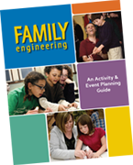
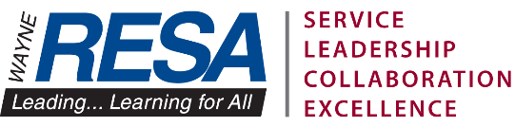

Family Engineering Kit
http://www.resa.net/elementaryengineering
If you would like to schedule the Family Engineering Kit for your school and you have attended Family Engineering training, please contact:

Richard Bacolor or Linda Olinik
bacolor@resa.net or olinikl@resa.net
(Please email the form to either Richard or Linda)

Please provide the following information:

Teacher Name:

School:

Grade Level:

District:

Phone Number:

Email Address:

Requested Pick-Up Date:

Requested Return Date:

It is your responsibility to pick up the Family Engineering Kit from Wayne RESA and return it to Wayne RESA. Please use the Family Engineering Kit responsibly and return the kit organized and with all the materials intact for the next group to have a successful event. Thank you.

