Background:

The alkaline earth metals - beryllium, magnesium, calcium, strontium, barium, and radium - are a reactive group of metals. Because they combine easily with many other elements, the alkaline earth elements are not found on Earth in the form of their free metals. The alkaline earth metals react with water, acids and bases, and many nonmetals, including oxygen, sulfur, and the halogens. By comparing how fast or how vigorously different metals react, it is possible to rank the metals in order from most active to least active both across a period and within a group.

Similarities and differences among the elements on the periodic table give rise to periodic trends, both across rows and within columns of the table. Recognizing periodic trends and chemical properties of the elements is important to understanding the full value of the periodic table. In this experiment, you will observe a series of reactions (chemical reactivity and solubility) for several alkaline earth metals. From this data, you will be able to determine the periodic trend for the metals across a period and within a group.

Objectives:
- Identify periodic trends in the activity and solubility of the alkaline earth metals.
- Determine the trends across a period (Part A) and within a group (Part B).
- Use reactivity data (Part A) and solubility data (Part B) to observe differences in reactivity.

Procedure:

Part A. Activity of Metals

1. Obtain a reaction well plate to run your experiments.

2. You will test 3 different metals (Ca, Mg, and Al) with 2 different liquids (water and hydrochloric acid). You will also test each reaction with a piece of red litmus paper. Note: Red litmus will stay red in acids or neutral solutions and turn blue in basic solutions.

Record observations for any immediate reactions. You should also make observations after 1-2 minutes, focusing on comparing the rates of reaction. Please clean your reaction plate before moving on to Part B.

Data Table

 | Calcium | Magnesium | Aluminum
Reaction with H₂O  Observations (Initial and Final) | reaction to produce a gas (hydrogen) | no reaction | no reaction
Litmus test | turns blue (basic) | not any | not any
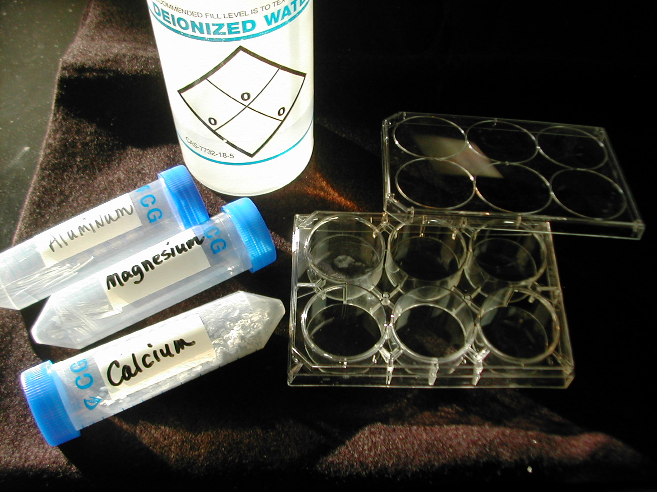

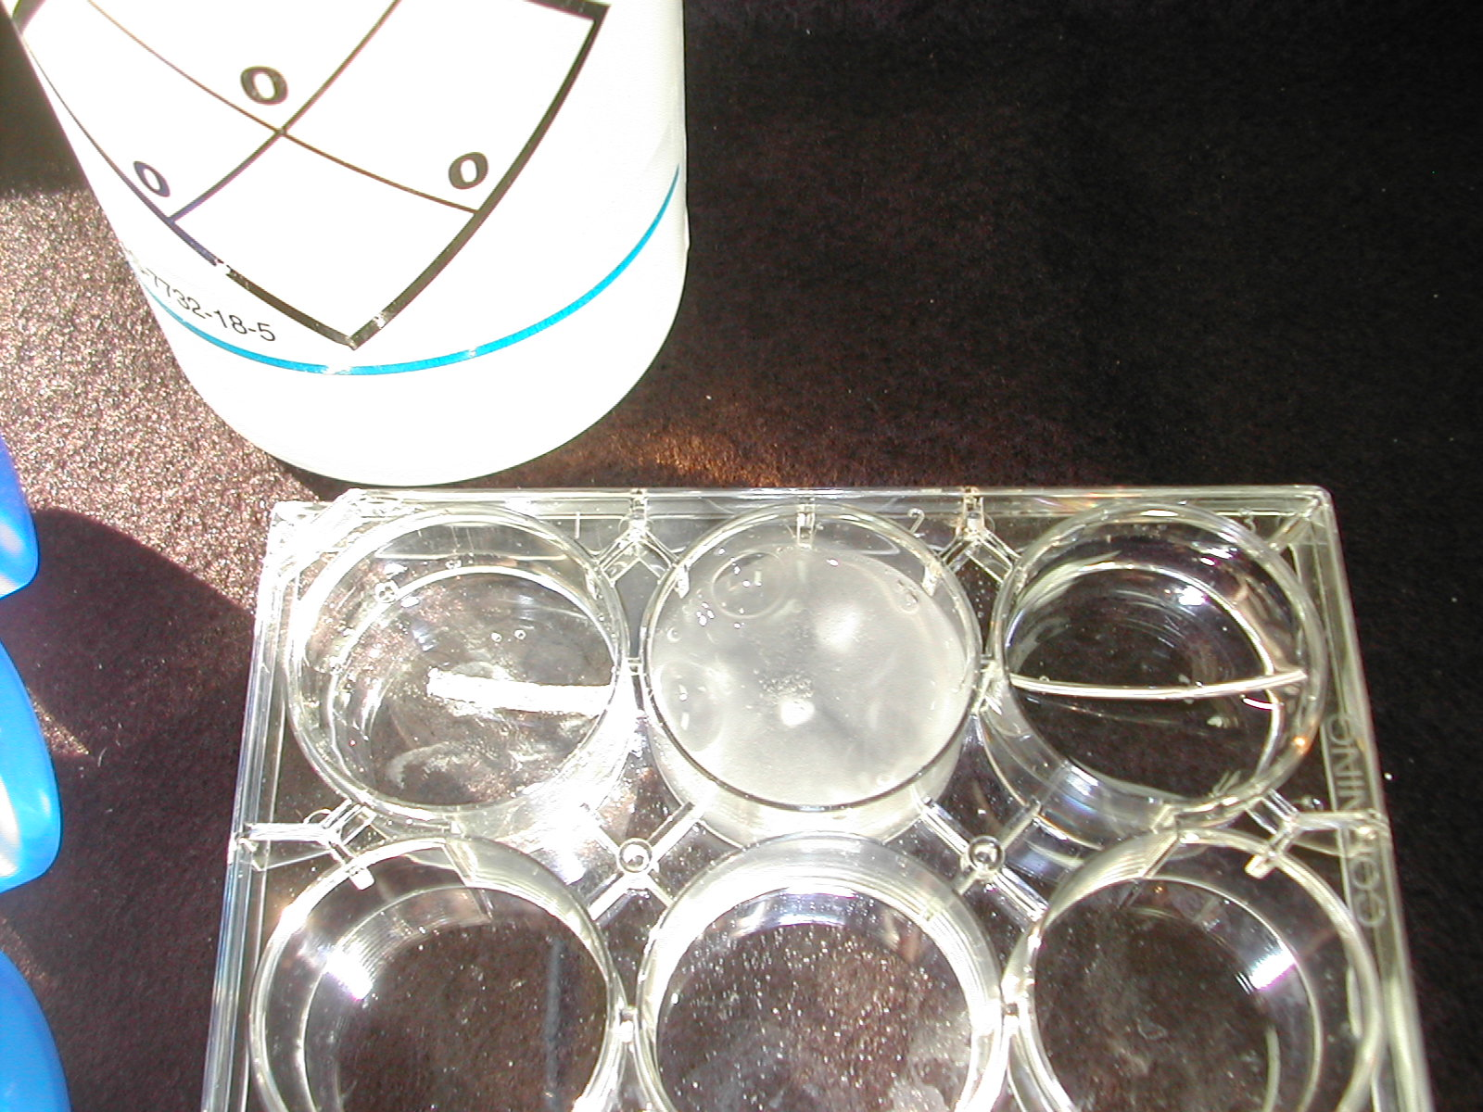

 | Calcium | Magnesium | Aluminum
Reaction with HCl  Observations  (Initial and Final) | reaction to produce a gas (hydrogen) | reaction to produce a gas (hydrogen) | no reaction
Litmus test |  |  | not any

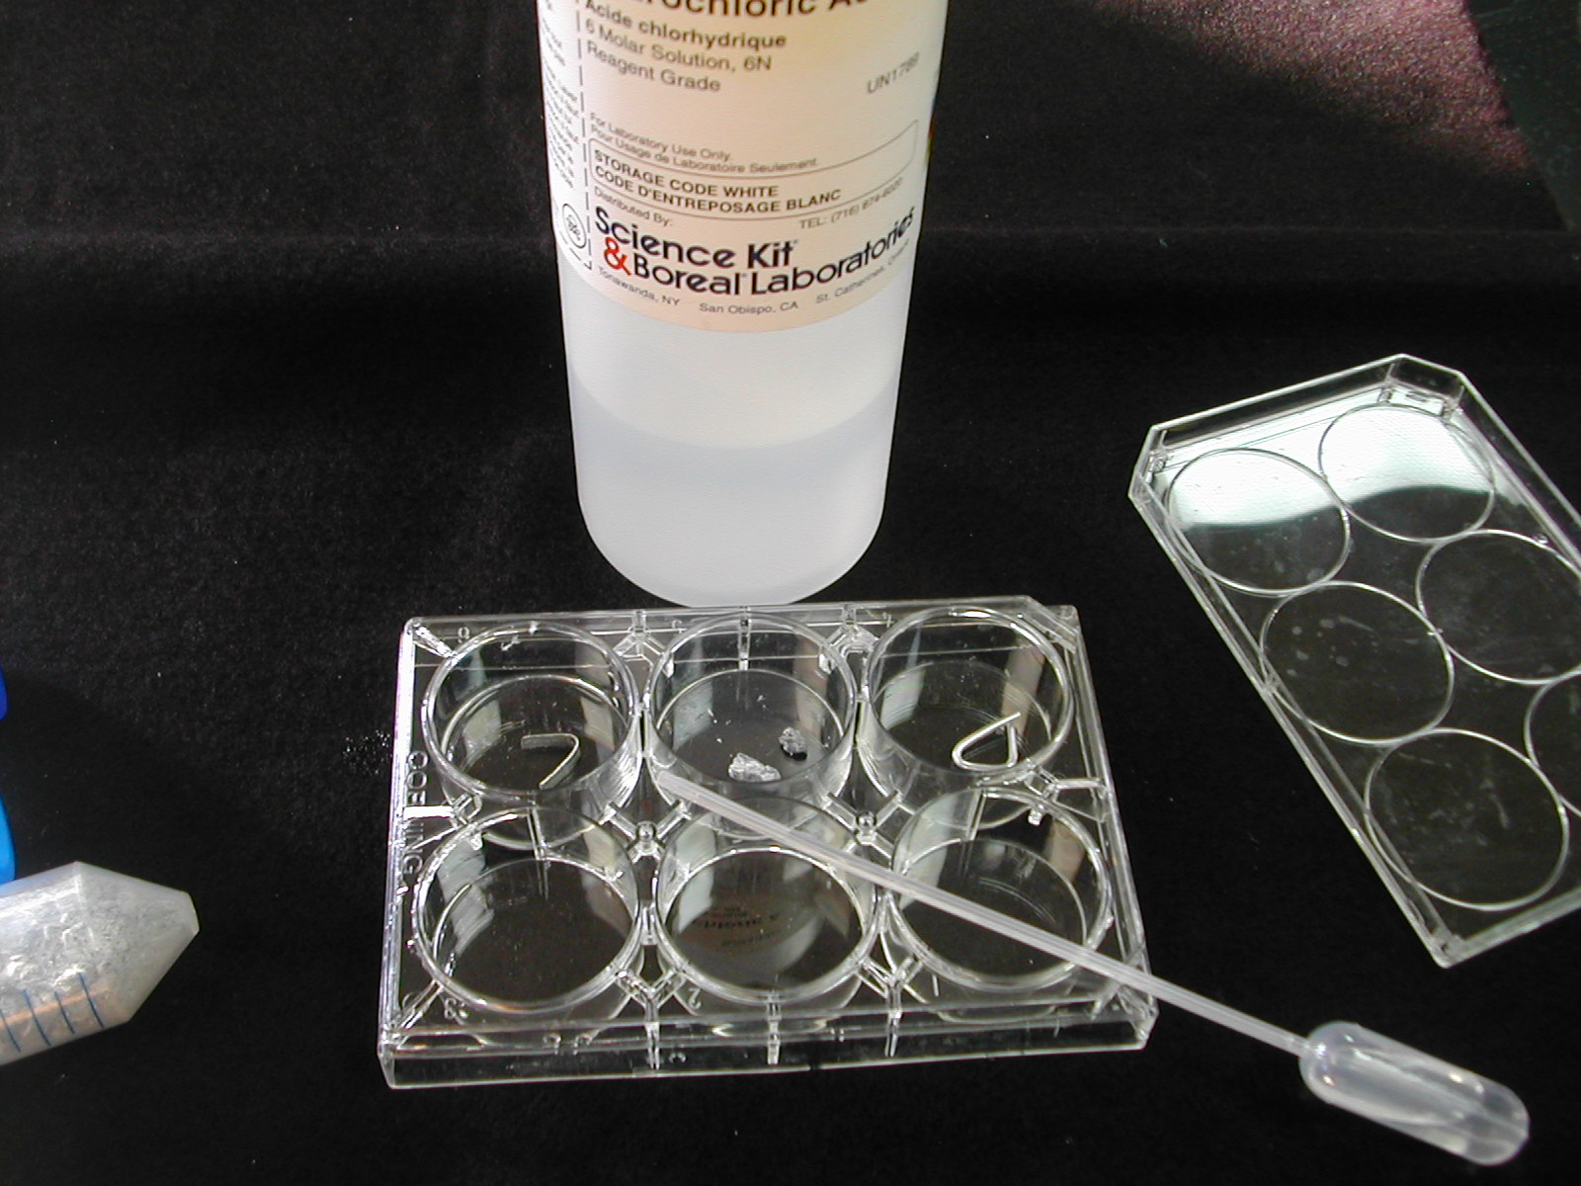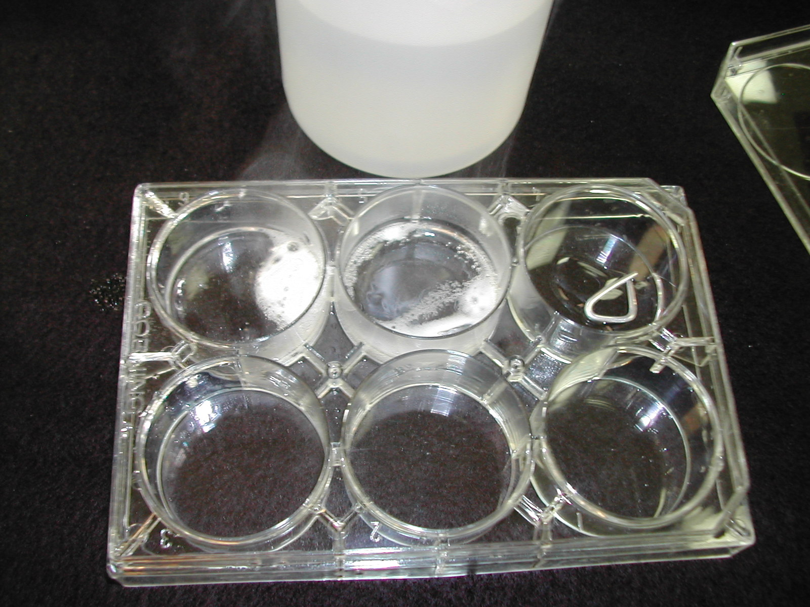

Part B. Solubility of Alkaline Earth Metal Compounds
1. You will use your reaction well plate for part B. In this part, you will mix 4 known metal solutions with 4 testing solutions ( Na₂CO₃, Na₂SO₄, (NH₄)₂C₂O_{4,} and KIO₃). Each of the four known metal solutions contains a member of the alkaline earth family (Mg²⁺, Ca²⁺, Sr²⁺, Ba²⁺).

2. Your goal is to arrange the four elements in order of reactivity. When mixing the solutions, look for the presence of precipitates (solids that form from 2 solutions). Cloudiness is a key observation to indicate presence of a solid.

Data Table:
Alkaline Earth Metal Ion (Below) | IO₃ ¹⁻ | SO₄ ²⁻ | CO₃ ²⁻ | C₂O₄ ²⁻
Mg ²⁺ |  |  | ppt
Ca ²⁺ |  |  | ppt | ppt
Sr ²⁺ |  | ppt | ppt | ppt
Ba ²⁺ | ppt | ppt | ppt | ppt

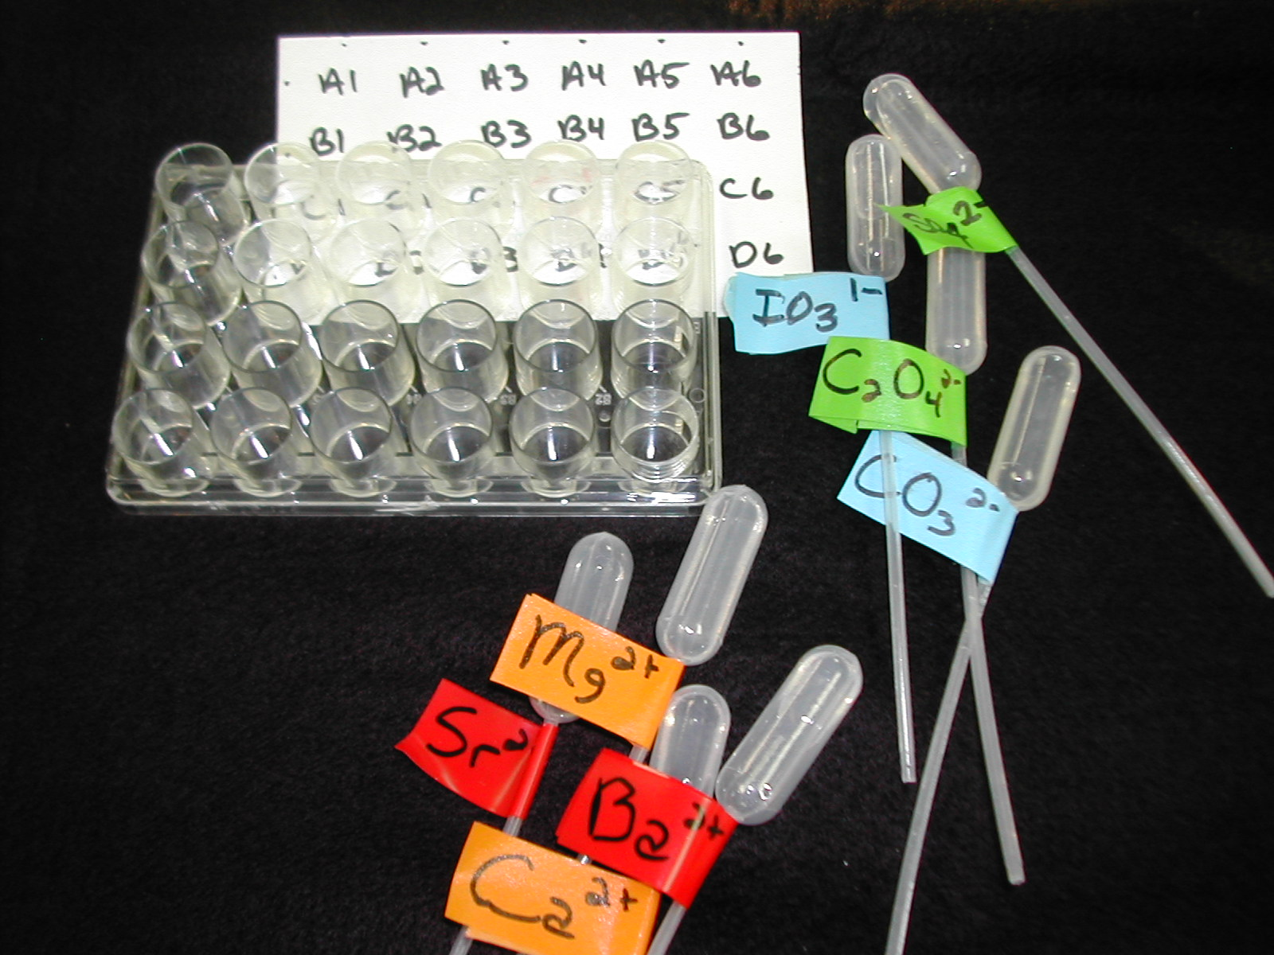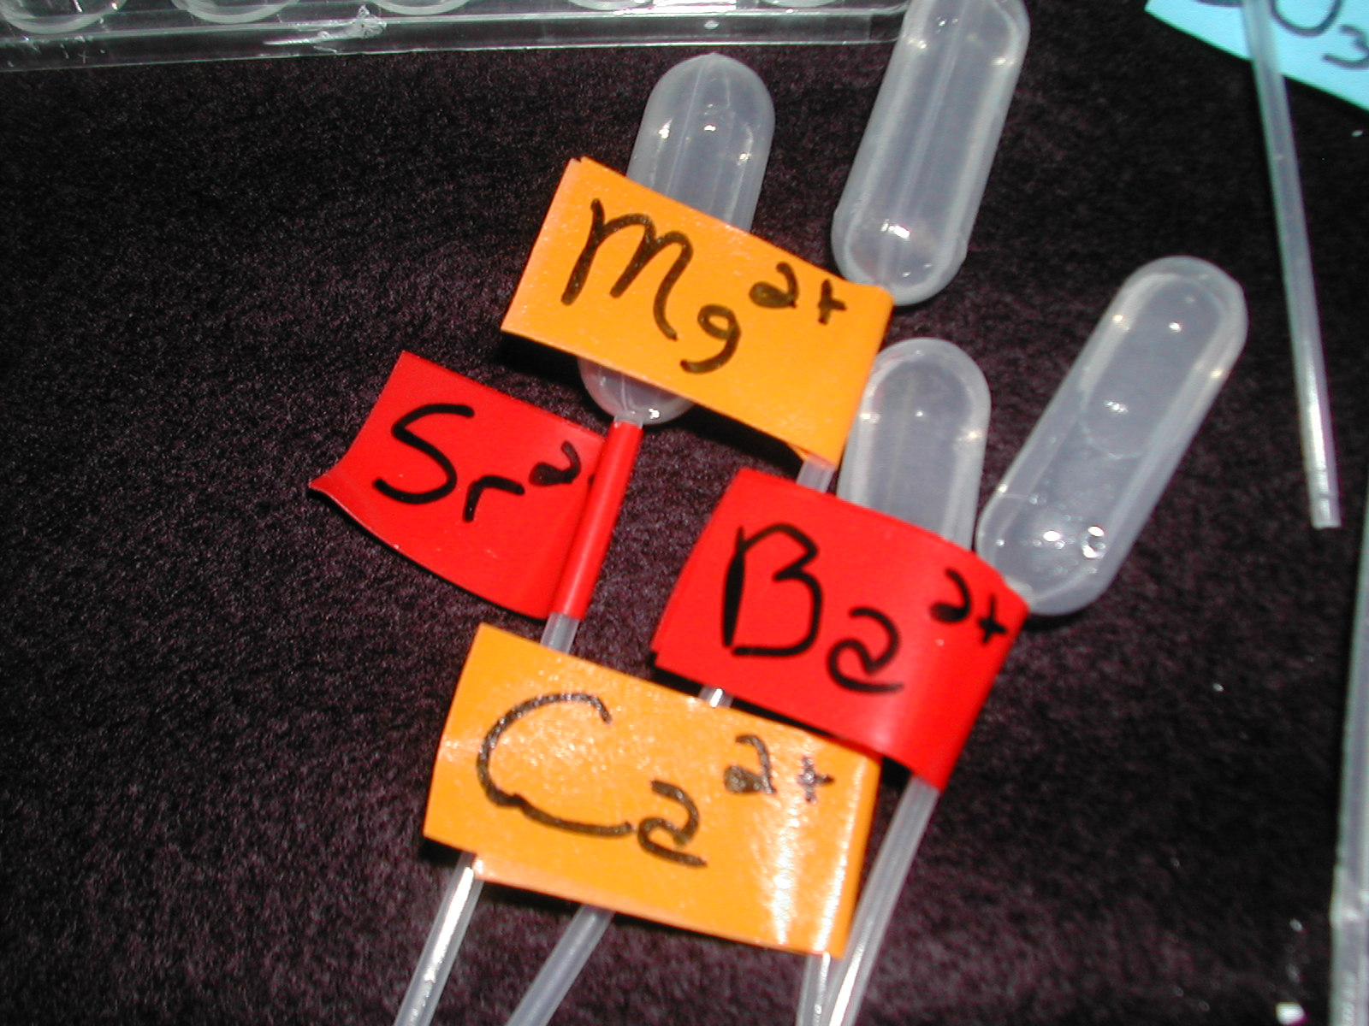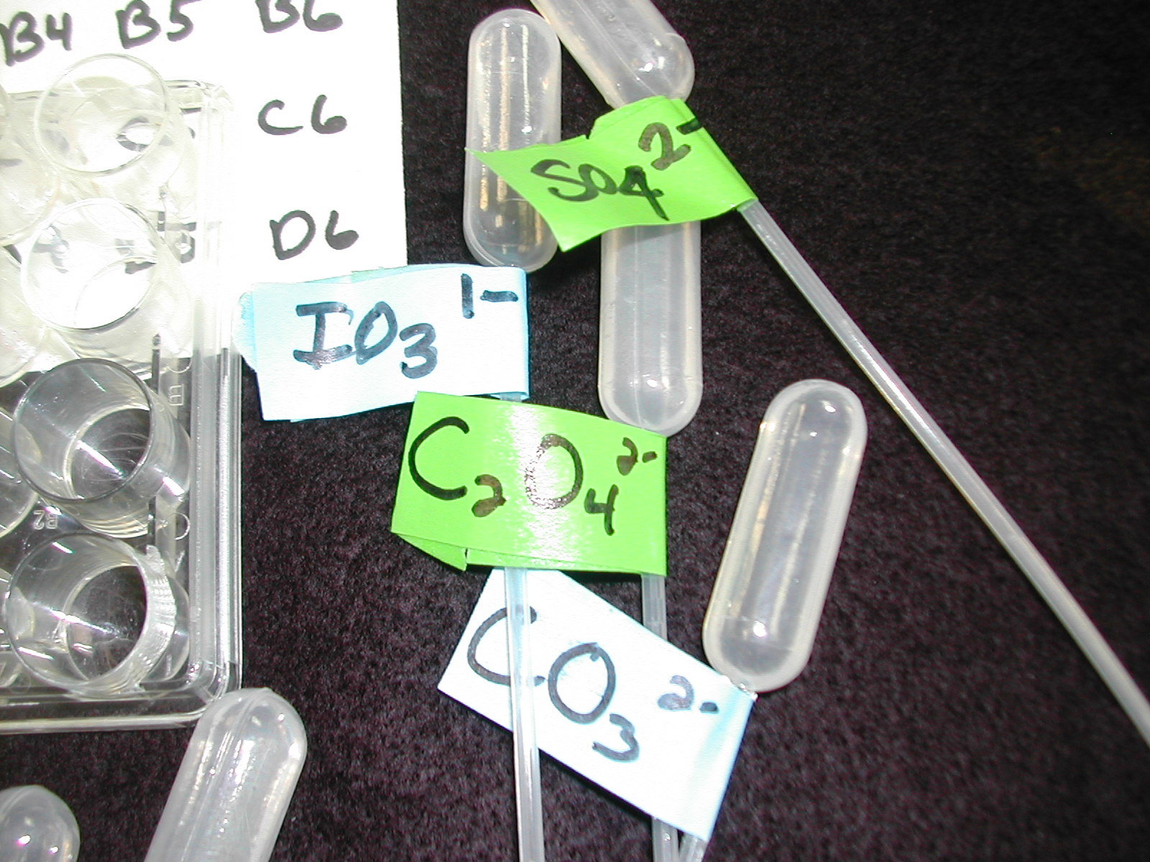

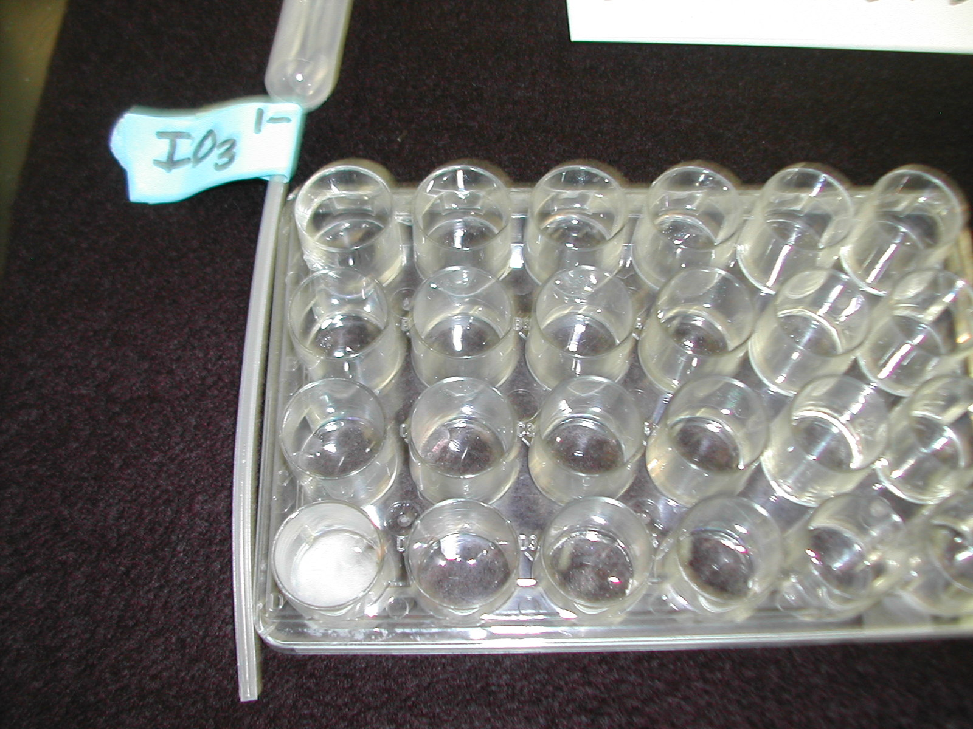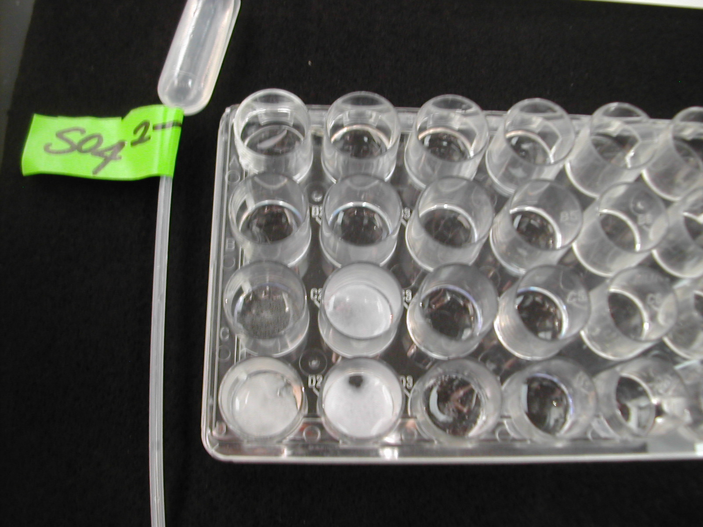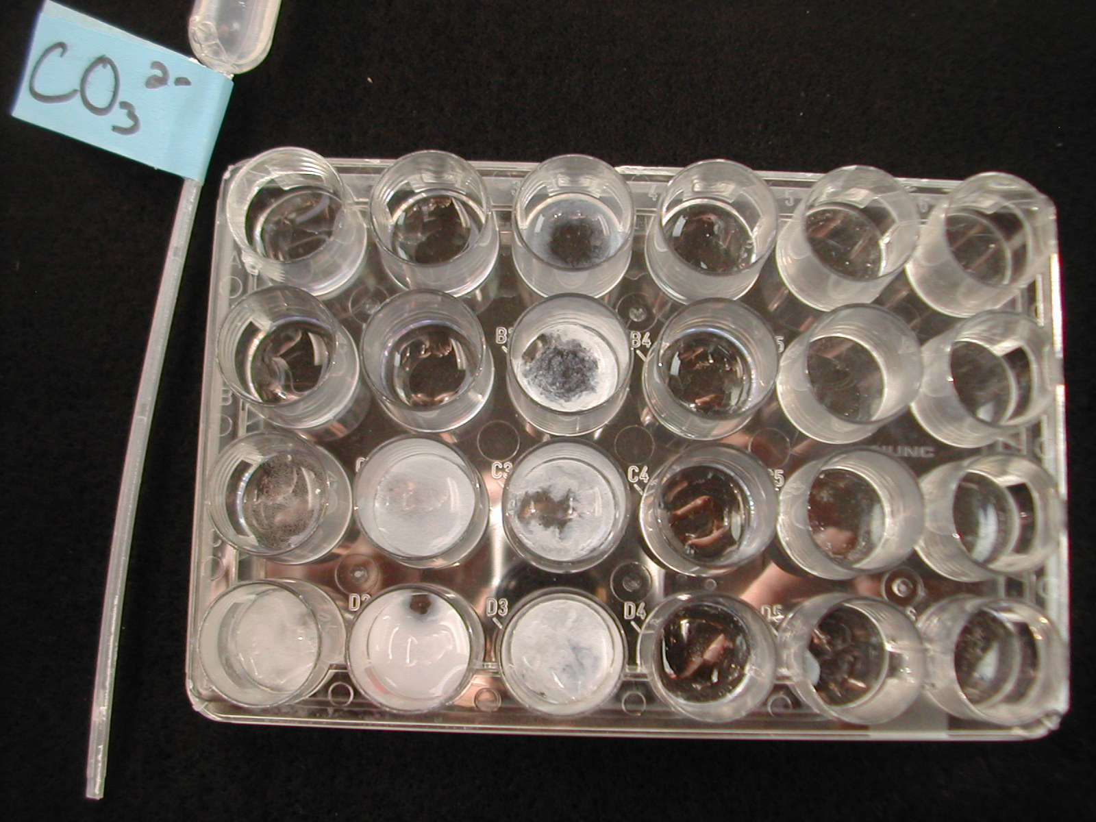

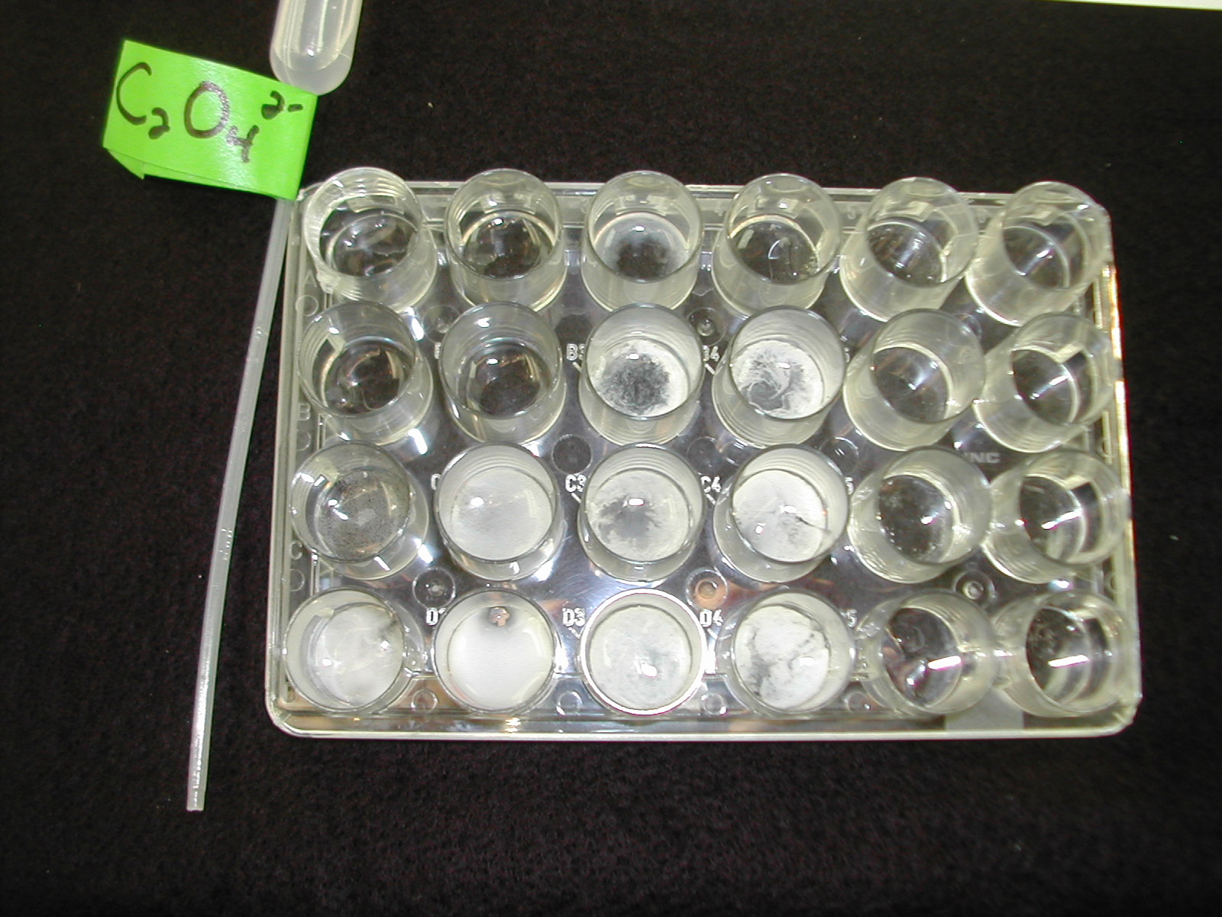
Analysis Questions -

1. Which alkaline earth metal, magnesium or calcium, is more active? Cite your evidence.

2. Which period 3 metal, magnesium or aluminum, is more active? Cite your evidence.

3. Write a general statement that describes the periodic trend in metal activity within a group (vertical column) of the periodic table and across a period (horizontal row) using your data from part A.

4. Locate the following metals on the periodic table: magnesium, potassium, and sodium. Based on your data, rank these metals in order of their expected activity, from most active to least active.

5. In part B, which alkaline earth metal formed the most precipitates? The fewest?

6. Write a general statement that describes the periodic trend in the solubility of alkaline earth metal compounds.

