Lab
Unit 9 2.2d
Air is a Fluid
Materials
- Baking soda
- Vinegar
- 500 ml beaker or glass jar of similar size
- Candle (a small votive candle is ideal)
- Matches
- Strip of poster board or cardboard about 12" by 3" (old file folders work
- well)
Procedure
- Discuss the physical properties of a fluid with students. Be sure to include the idea that fluids can be poured. Ask students if they think air is a fluid. Ask how it could be demonstrated.

2. Fold the poster board or cardboard lengthwise.

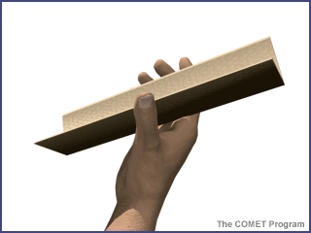

3. Place the candle on a plate and light the candle.

4. Put about a tablespoon of baking soda in the glass jar beaker.

5. Pour about 1/4 cup of vinegar in the jar or beaker. (The vinegar and baking soda will react immediately filling the jar with carbon dioxide gas.)

6. When the fizzing subsides, hold the poster board "funnel" at an angle so that one end is near the candle flame and the other end is slightly higher.

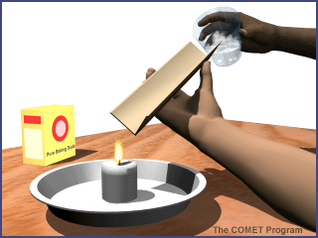

7. "Pour" the gas in the beaker or jar down the funnel. The flame will go out in a second or two.

Observations and Questions
- 1. What happens when the vinegar and baking soda are mixed? (The mixture froths and bubbles,
producing carbon dioxide.)

2. Explain how the flame was extinguished. (There was no more oxygen available for the flame, so it went out. Pure carbon dioxide is denser than air, so it flows like a liquid from the jar or beaker along the funnel. Carbon dioxide is used in fire extinguishers because it is effective at smothering flames.)

